**Ambavaram Tirumala Kondareddy(192210642)**

**3. Develop a flowchart in Figma depicting the operation of a Network Switching Subsystem in a mobile cellular system.**

**Aim: -**

**To draw a flowchart in Figma depicting the operation of a Network Switching Subsystem in a mobile cellular system**

**Procedure: -**

**1. open Figma**

**2. Create a new file**

**3. Click on the resources icon and click on the plugins**

**4. Search for the Flow Chart**

**5. Drag and drop the shapes on the screen**

**6. Now, enter the content on the shapes and connect them through Arrows.**

**7. Grouping and alignment**

**8. Review and edit**

**9. Save and share**

**Design: -**

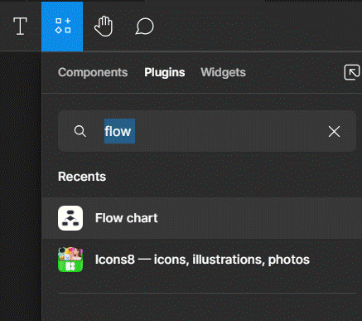

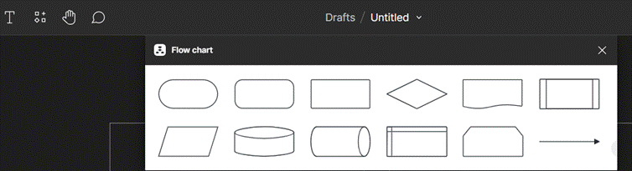

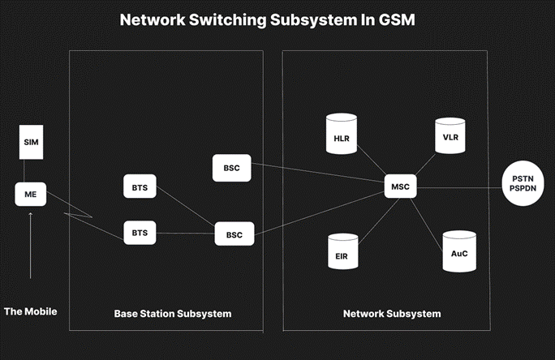

**Result: -**

Hence the flowchart in Figma depicting the operation of a Network Switching Subsystem in a mobile cellular system has been drawn successfully